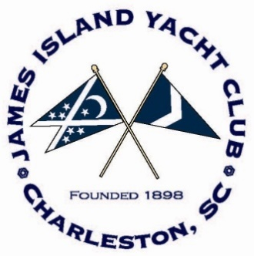

Notice of Race

James Island Yacht Club Regatta

James Island, South Carolina

June 15 - 16, 2019

(Updated June 3, 2019)

**1. RULES:**

1.1 This regatta will be governed by current version of *The Racing Rules of Sailing 2017 – 2020* (RRS).

1.2 The US Sailing prescriptions to rules 63.2 and 63.4 are deleted.

1.3 Appendix V will be in effect.

1.4 The NOR for the 2019 SAYRA Jr. Grand Prix.

**2. ELIGIBILITY:**

2.1 The regatta is open to yachts of all classes.

2.2 Classes with four or more boats entered may compete as a class.

2.3 Sea Island One Design and all Junior classes need only three boats entered.

**3. REGISTRATION and ENTRY FEES:**

3.1 Online registration is available on Yacht Scoring (YachtScoring.com).

3.2 All Junior Classes $ 35 (includes 1 Regatta T-shirt)

(Anyone 16 years of age and younger)

Single hand Classes $ 40

Double $ 50

Three Person $ 55

Four Persons or more $ 65

**4. SCHEDULE:**

Friday June 14 1800 – 2000 Registration will be at James Island Yacht Club.

1900 - 2200 Cocktail Party.

Saturday June 15 0900 – 1100 Registration will be at James Island Yacht Club.

1100 Welcome and Skipper’s Meeting

1230 First Warning, Junior Course

1255 First Warning, Open and Big Boat Courses

1730 Live Music under the pavilion.

1800 Dinner / Beverages - Low Country Boil

Please Pre-Purchase – Info on Website

Sunday June 16 1155 First Warning, all courses.

Awards Ceremony following the Protest Time Limit

**5. SAILING INSTRUCTIONS and AREA:**

Sailing Instructions and course diagrams will be available at registration. All courses will be in Charleston Harbor.

**6. PENALTY SYSTEM:**

Appendix V will be elaborated in the sailing instructions.

**7. SCORING:**

7.1 An unlimited number of races are scheduled on all courses. One race completed will constitute a regatta.

7.2 The regatta will be scored with the low point system as described in RRS, Appendix A as amended to read that if more than 5 races are scored, each boat will exclude her worst score.

**8. PRIZES:**

The number of trophies awarded will be determined by the number of boats entering each class, as described in the Sailing Instructions.

**9. DISCLAIMER OF LIABILITY:**

Competitors participate in this regatta entirely at their own risk. See Rule 4, Decision to Race. James Island Yacht Club will not accept any liability for material damage or personal injury, or death sustained in conjunction with or prior to, during, or after the regatta.

**10. ADDITIONAL INFORMATION:**

In junction with the JIYC Open Regatta, the **2019 USSCA NORTH AMERICAN CHAMPIONSHIP** will be held at the James Island Yacht Club on June 12 – 16. Online Registration is available on Yacht Scoring (YachtScoring.com).

**10. CONTACT INFORMATION:**

For additional information please contact:

Ron Maguire Dan Cook

Club Manager Vice Commodore

James Island Yacht Club James Island Yacht Club

[manager@jiyc.org](mailto:manager@jiyc.org) [vicecommodore@jiyc.org](mailto:vicecommodore@jiyc.org)

843-795-6060